To Parents and Carers of Pupils
Reydon Primary School

22 October 2014

Dear Parent/Carer,

Reydon Primary School and the Active Learning Trust - Consultation

I am writing to let you know that the Governing Body of the school has voted unanimously to apply to the Secretary of State for Education for Reydon Primary School to become an academy as part of the Active Learning Trust. The Trust would become the sponsor for the school and will assist us in our continued plans to support all our pupils to maximise their potential in their time in this school.

We are delighted to advise that the Secretary of State has now issued an academy order which means that the governing body, with the Trust, can now consult on the school becoming an academy. The date the Secretary of State has set is 1st March 2015.

As part of the process of moving to academy status, the governing body and the Trust wish to consult you (and other interested parties such as other local schools) on our plans to become an academy. More details about academies can be found on the Department for Education website at:

http://www.education.gov.uk/schools/leadership/typesofschools/academies/b00205692/whatisanacademy

If you have any questions about the school becoming an academy, representatives of the Governing Body and the Active Learning Trust will be available in school on 10 November at 2.30 p.m. to meet parents and carers as part of the consultation exercise. If you have any comments on our plans please do write to Mr. Charles Morris, Interim Headteacher, at the school or via email to admin@reydon.suffolk.sch.uk . The closing date for the consultation will be 17 November 2014 at 5.00 p.m.

Yours sincerely,
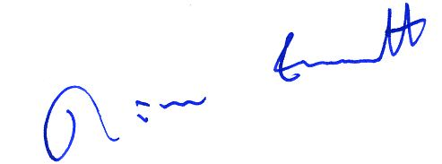

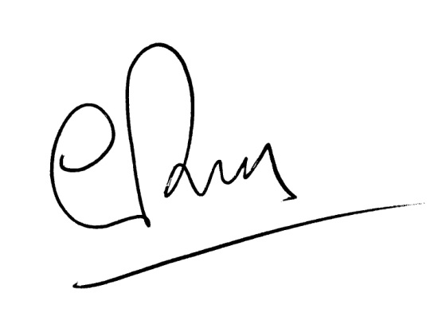
Chair of Governors

Clive Bush
Chief Executive
The Active Learning Trust

